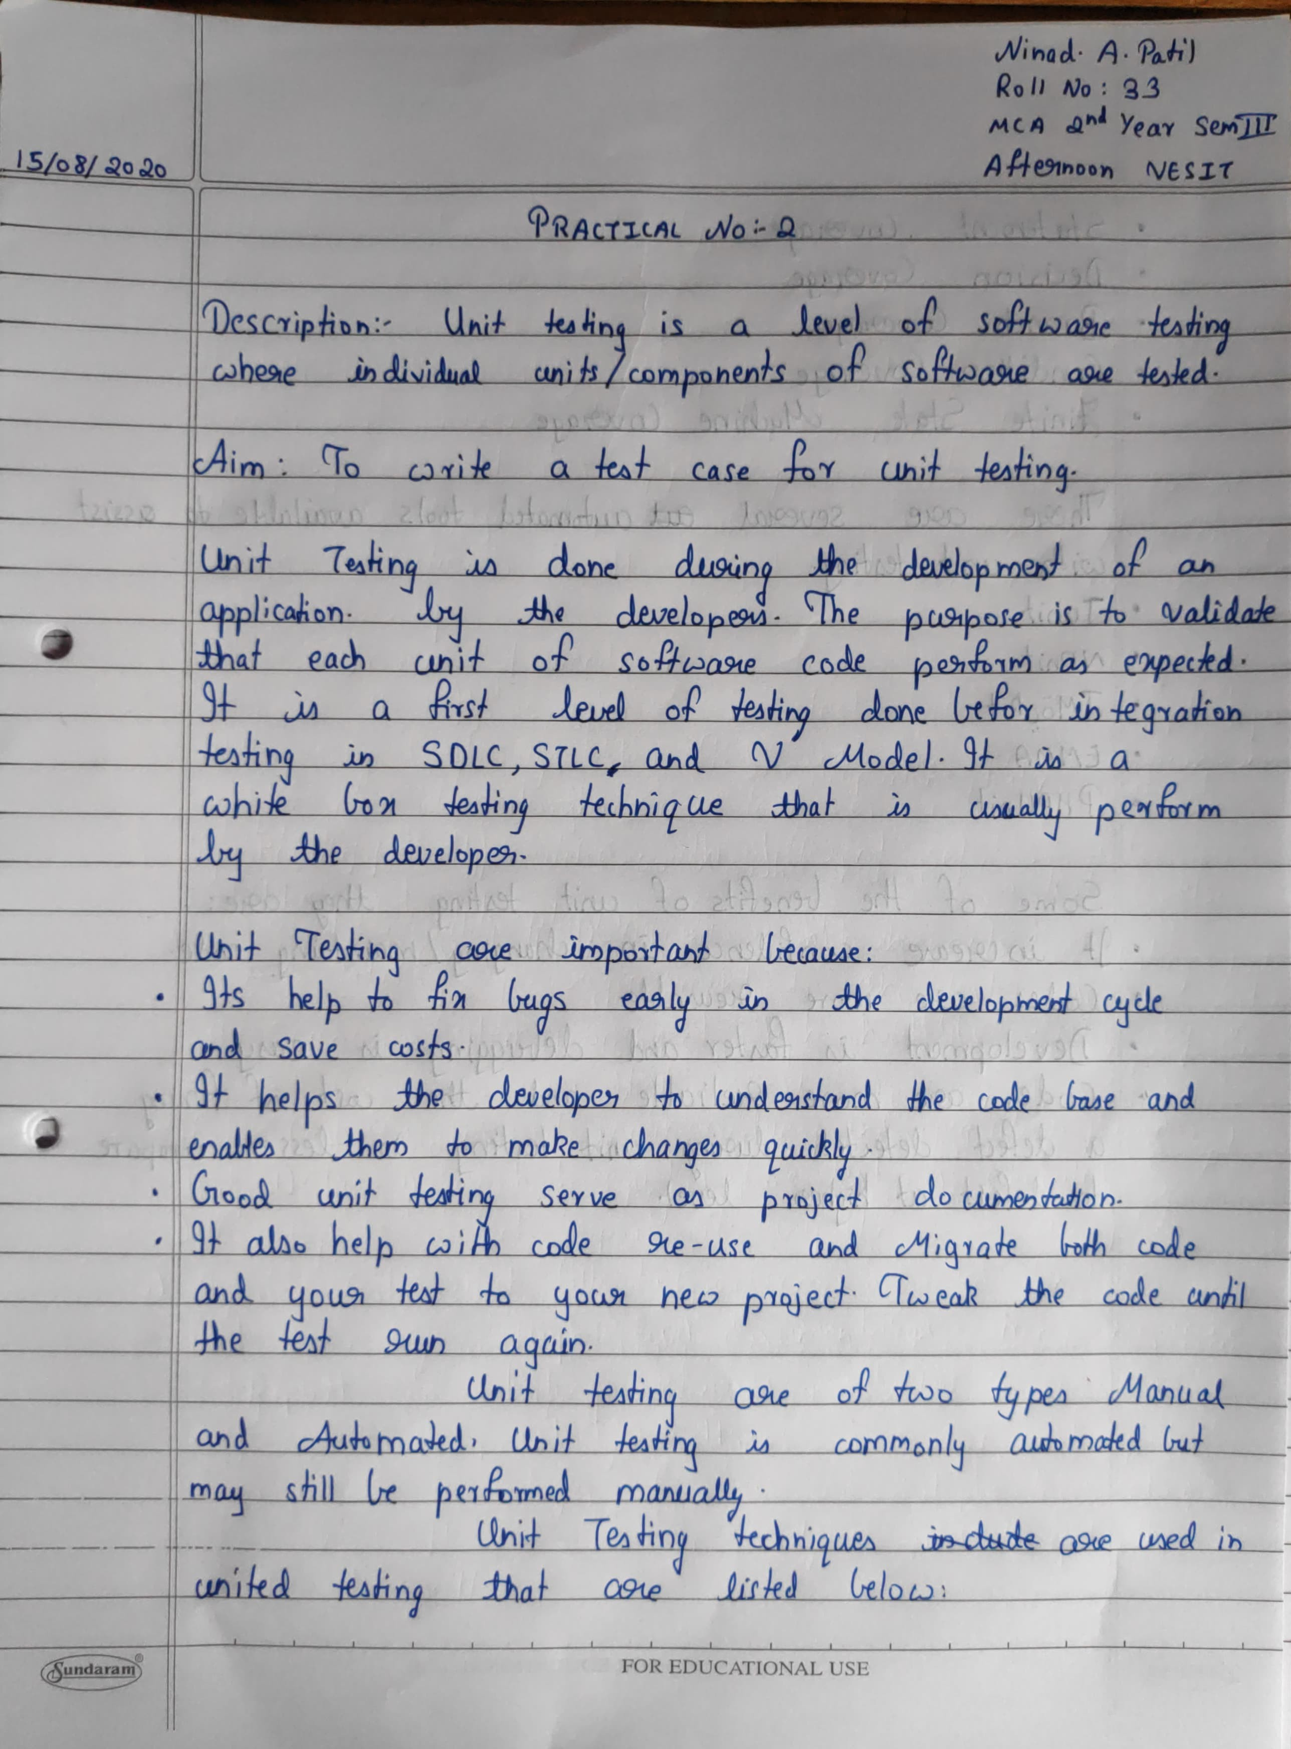

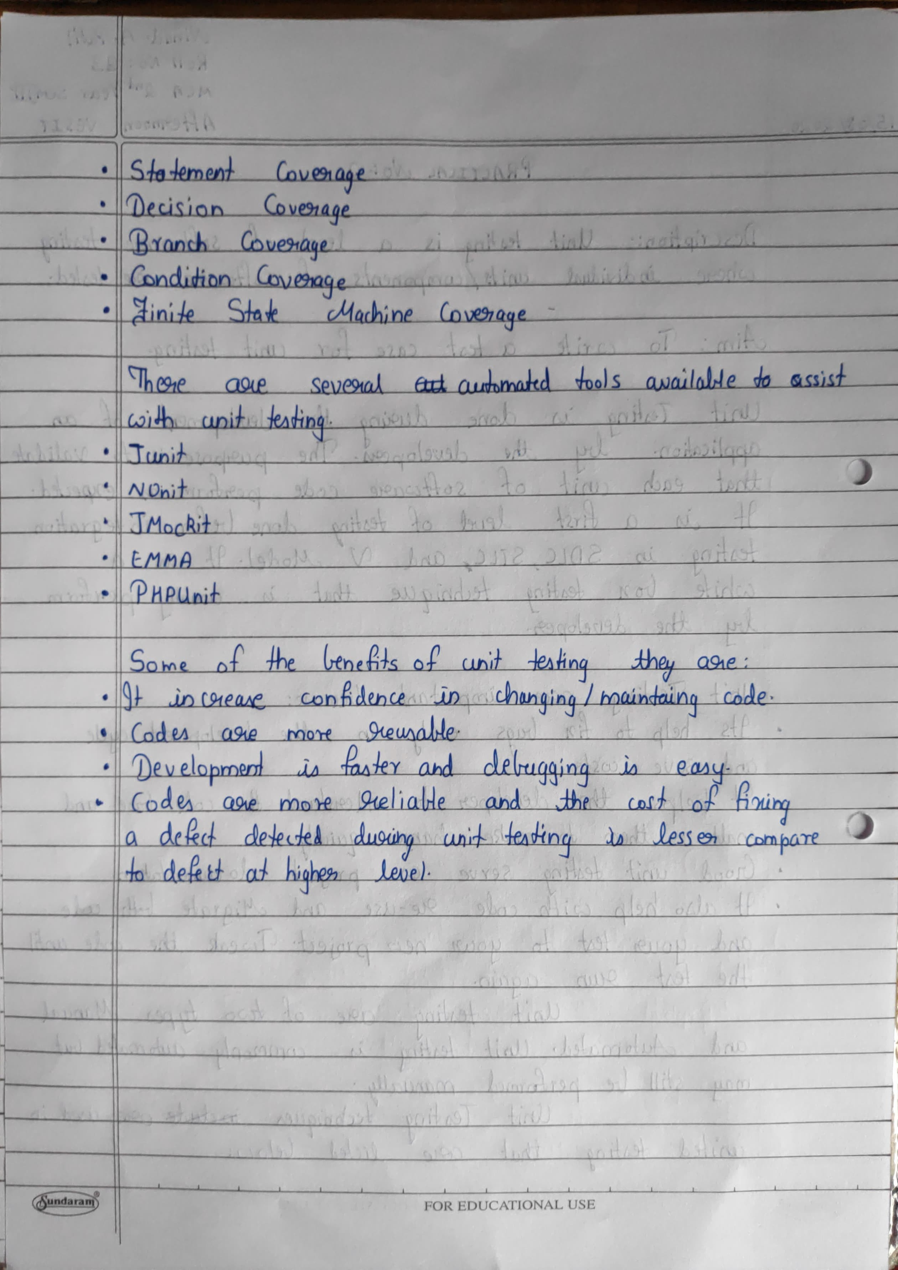

**Facebook Login Module**

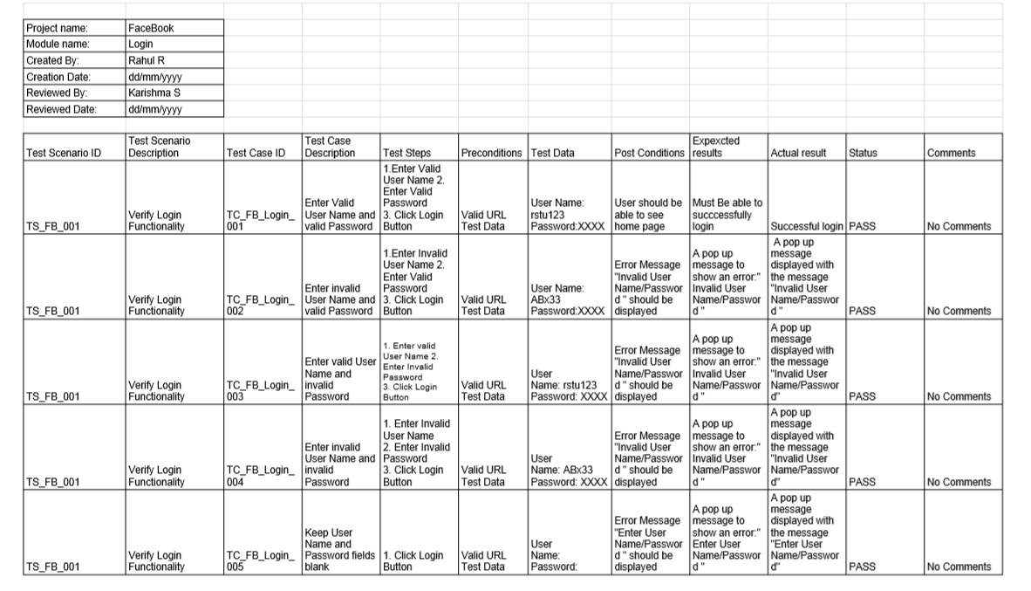

**Module 1: OpenCart Register Module**  
**Created by: Snehalkumar Palan (29) & Salwa Parkar (30)**

**Reviewed by: Nikita Patil (32) & Ninad Patil (33)**

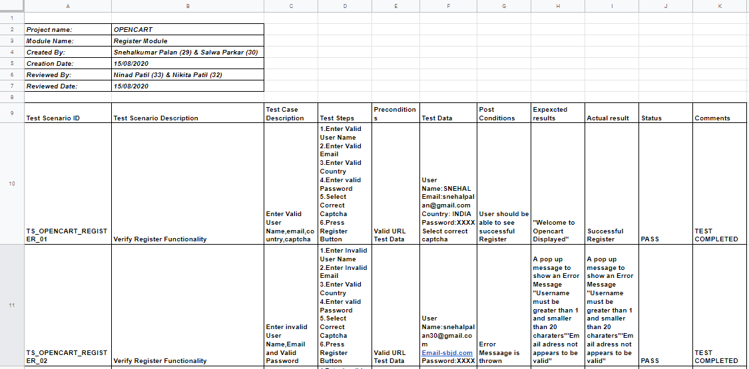

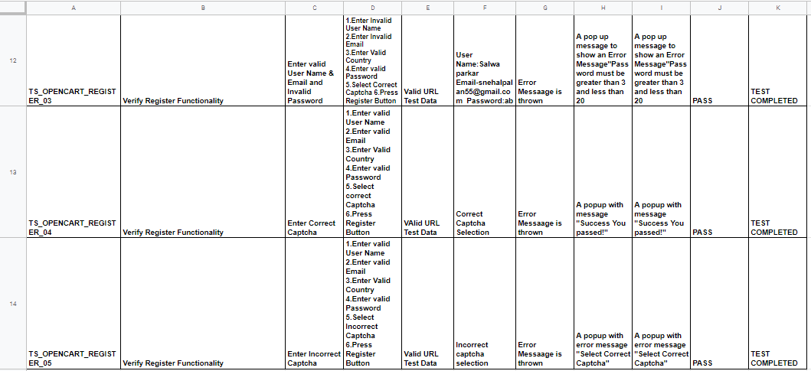

**REGISTER MODULE SCREENSHOTS**

* ID: -TS_OPENCART_REGISTER_01: -

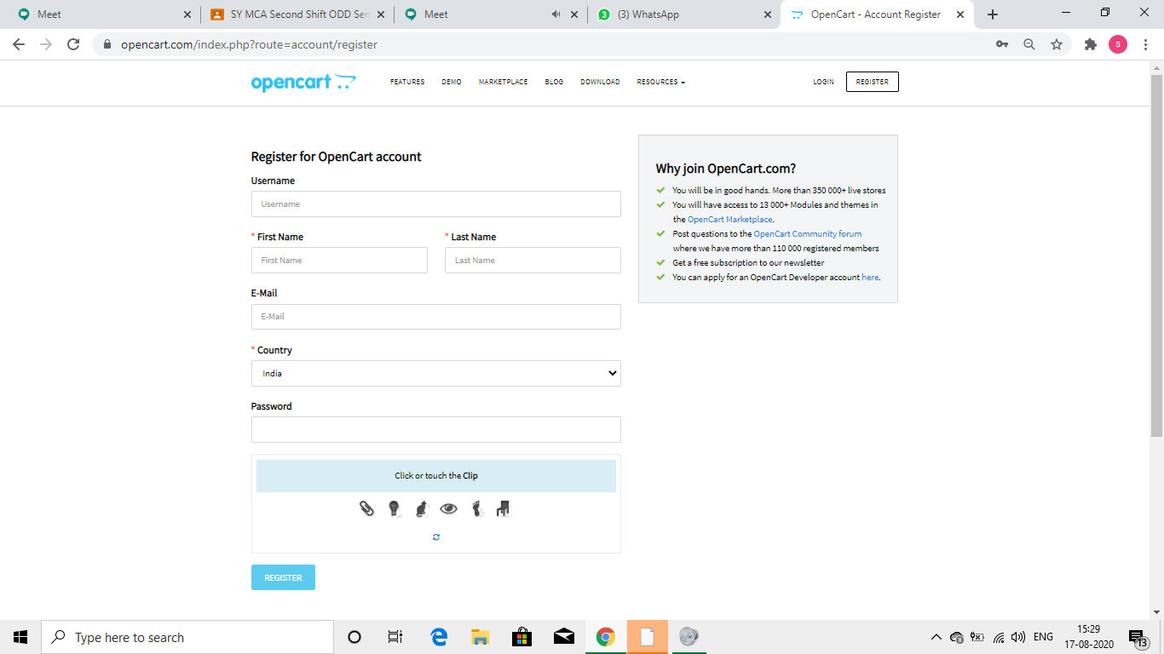

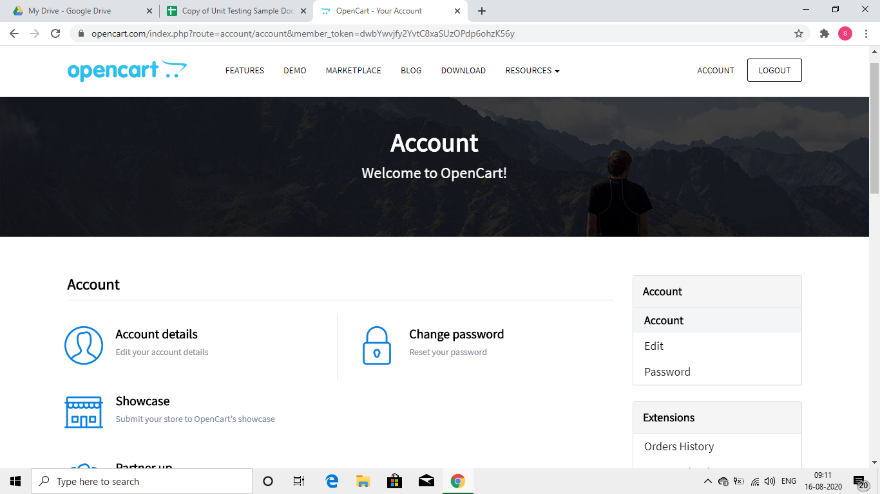

* ID: -TS_OPENCART_REGISTER_02: -

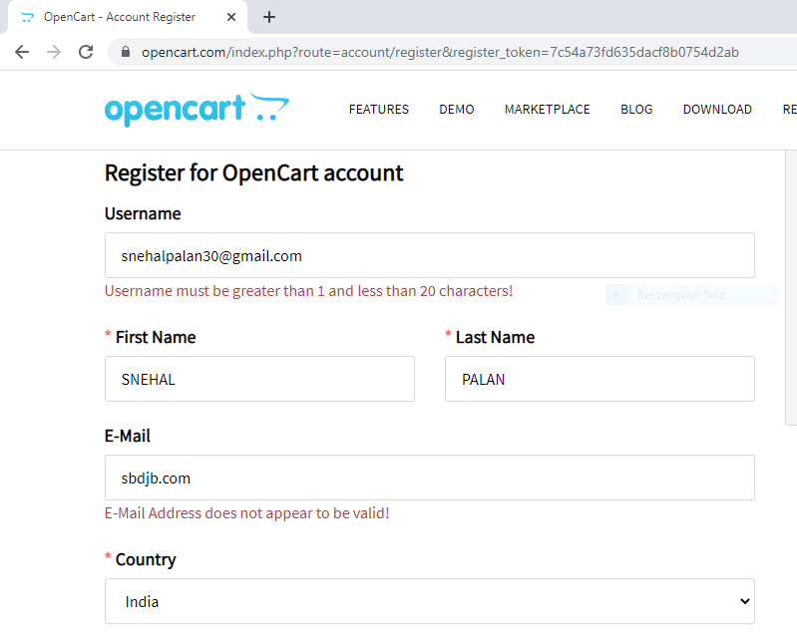

* ID: -TS_OPENCART_REGISTER_03: -

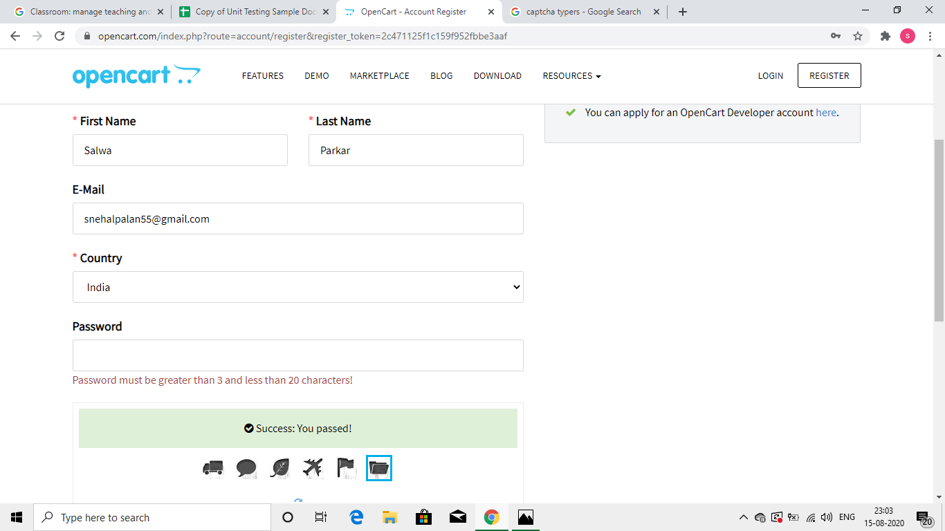

* ID: -TS_OPENCART_REGISTER_04: -

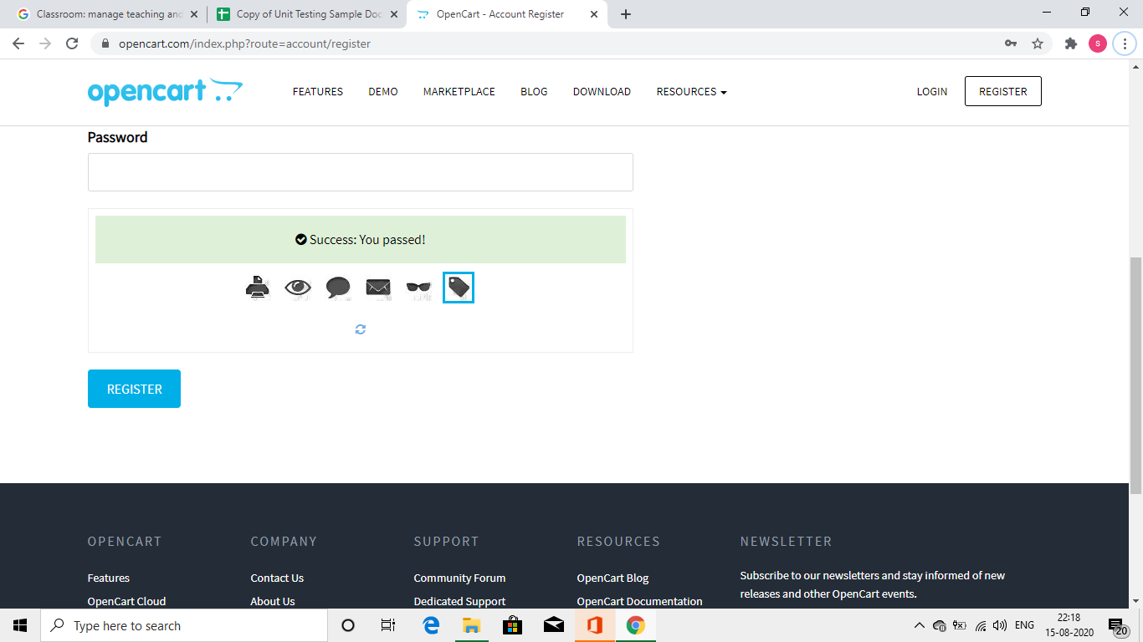

* ID: -TS_OPENCART_REGISTER_05: -

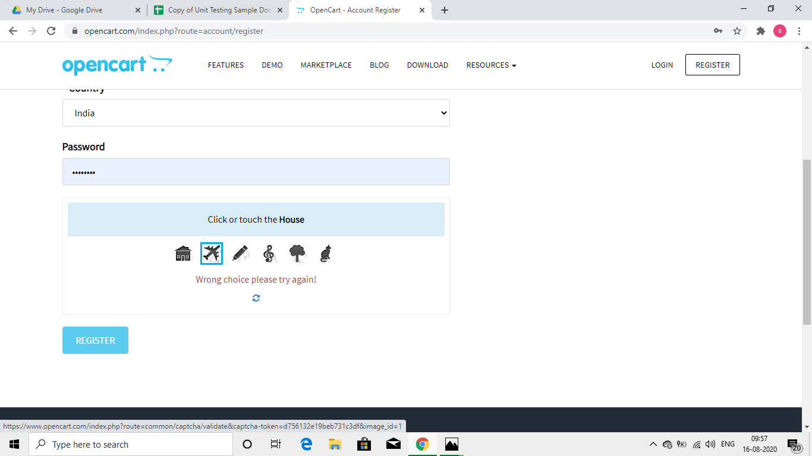

**Module 2: OpenCart Profile Upload Module**

**Created by: Nikita Patil (32) & Ninad Patil (33)  
Reviewed by: Snehalkumar Palan (29) & Salwa Parkar (30)**

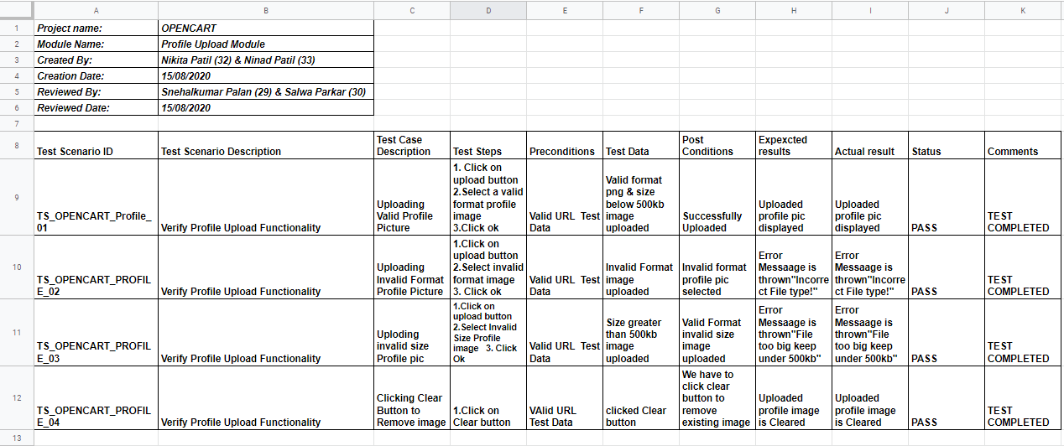

**PROFILE UPLOAD MODULE SCREENSHOTS**

* TS_OPENCART_Profile_01: -

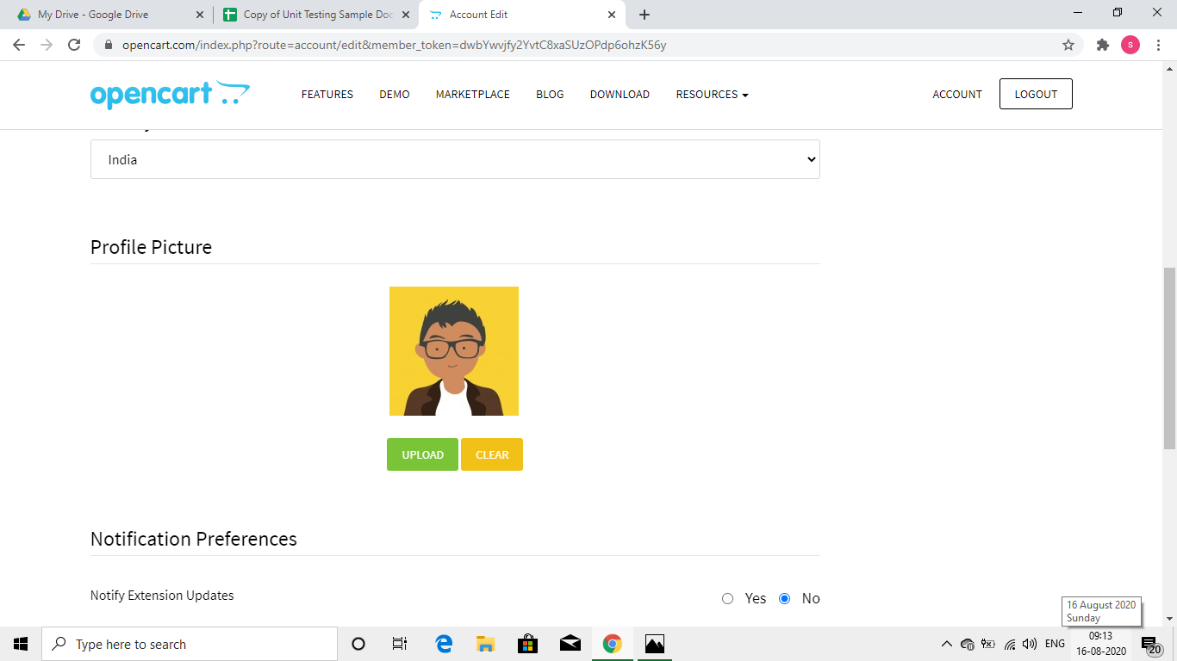

* TS_OPENCART_Profile_02: -

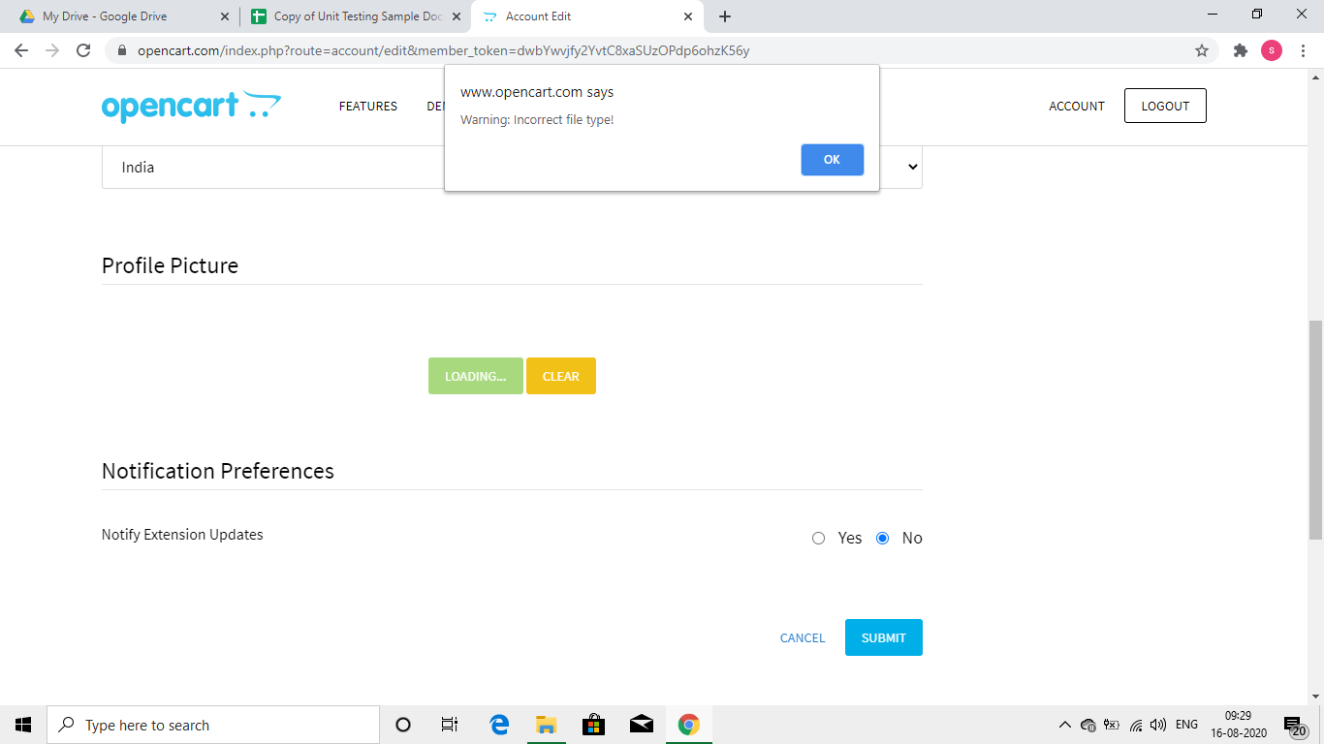

* TS_OPENCART_Profile_03: -

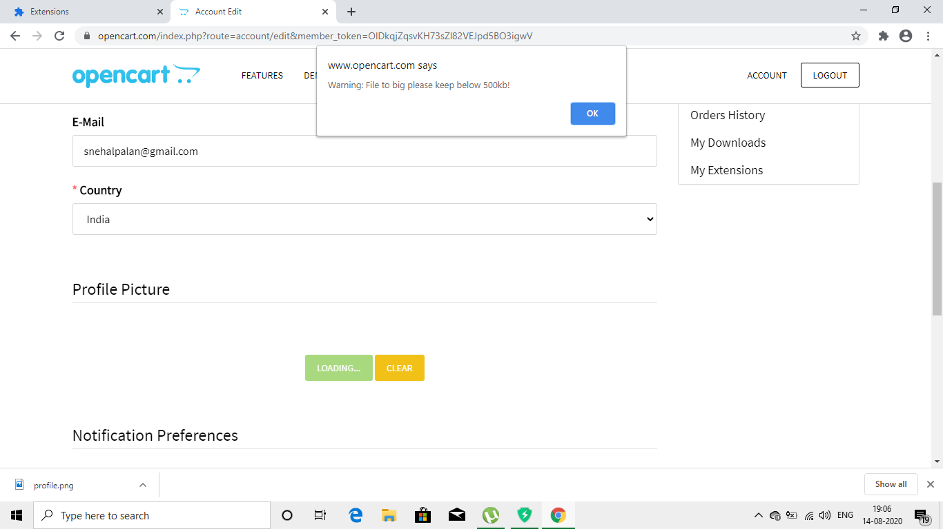

* TS_OPENCART_Profile_04: -

